Contents

Run XPub App 2

Opening Screen 3

View Accordion in Slide Out Mode 4

Administration Configure Screen 5

Record File Panel Toggle Switch 6

Admin Human Resources Screen 7

Employees Panel Auto Hide 8

Employees Panel Slide Out 9

Super Configure Screen 10

Record File Panel Toggle Switch 11

Super Job Management Screen 12

Jobs Section Various Screens 13

# Run XPub App

* First install .Net Core 3.1
  + Download this file windowsdesktop-runtime-3.1.14-win-x64 and run it to install core.
* Next unzip the release file
  + Download the release.zip file and unzip it
* Next Navigate to the netcoreapp3.1 directory
* Click on the Xpub.App application file to run the application.

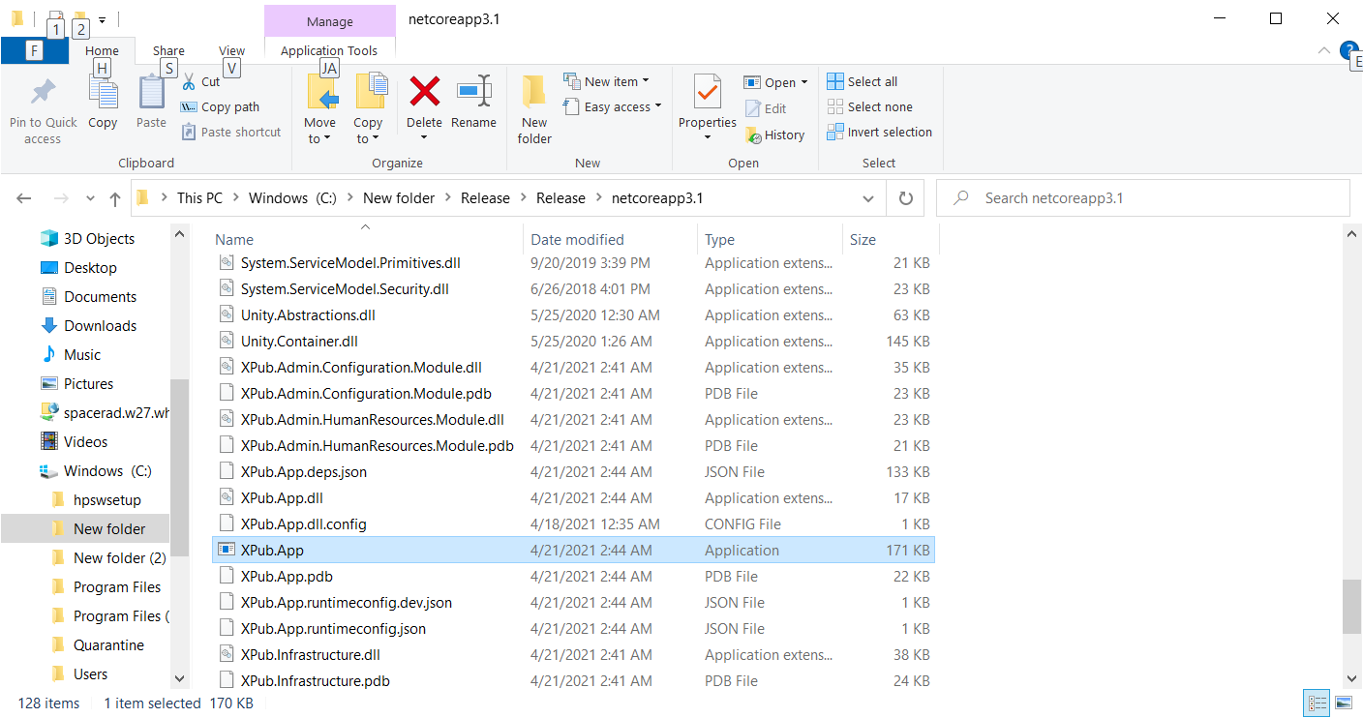

# Opening Screen

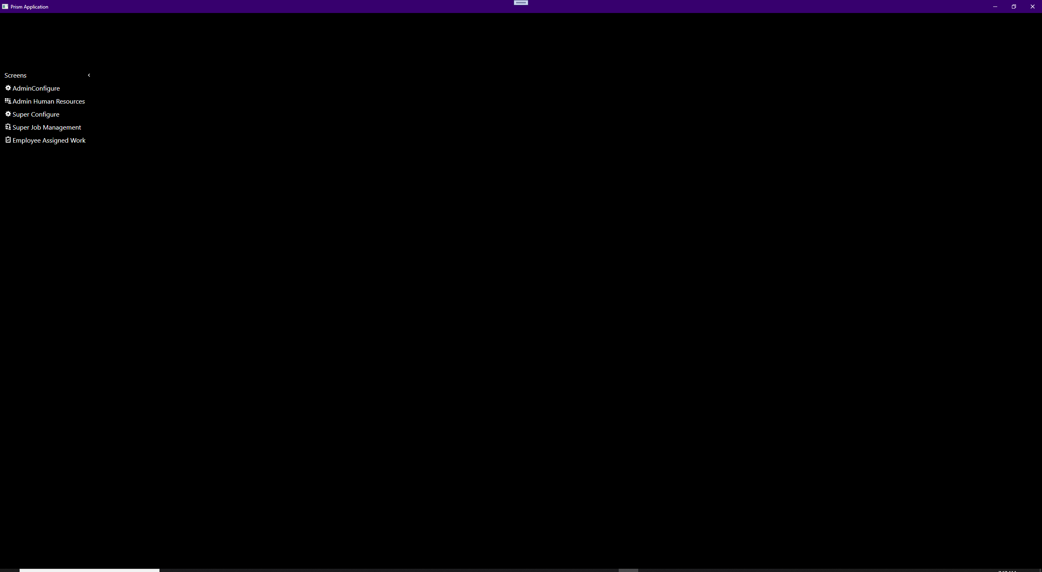

Screen presented on a monitor with a resolution of 2560 x 1400

Screen items selection represent a role’s screen:

* Admin Configure item
  + Role is Administration, Screen is Configure
    - Duplicate of Super Configure item’s screen.
    - Screen’s view format structure is similar to that of the Super Configure screen but needs to be modified.
* Admin Human Resources item
  + Role is Administration, Screen is Human Resources
    - Screen name may be changed to Employees since the screen’s functionality is managing employees.
* Super Configure item
  + Role is Supervisor, Screen is Configure
    - Screen name may be changed to Create Job since that is the screen’s functionality is to create a job.
* Super Job Management item
  + Role is Supervisor, Screen is Job Management
* Employee Assignment Task Item
  + Role is Employee, Screen is Assigned Task

# View Accordion in Slide Out Mode

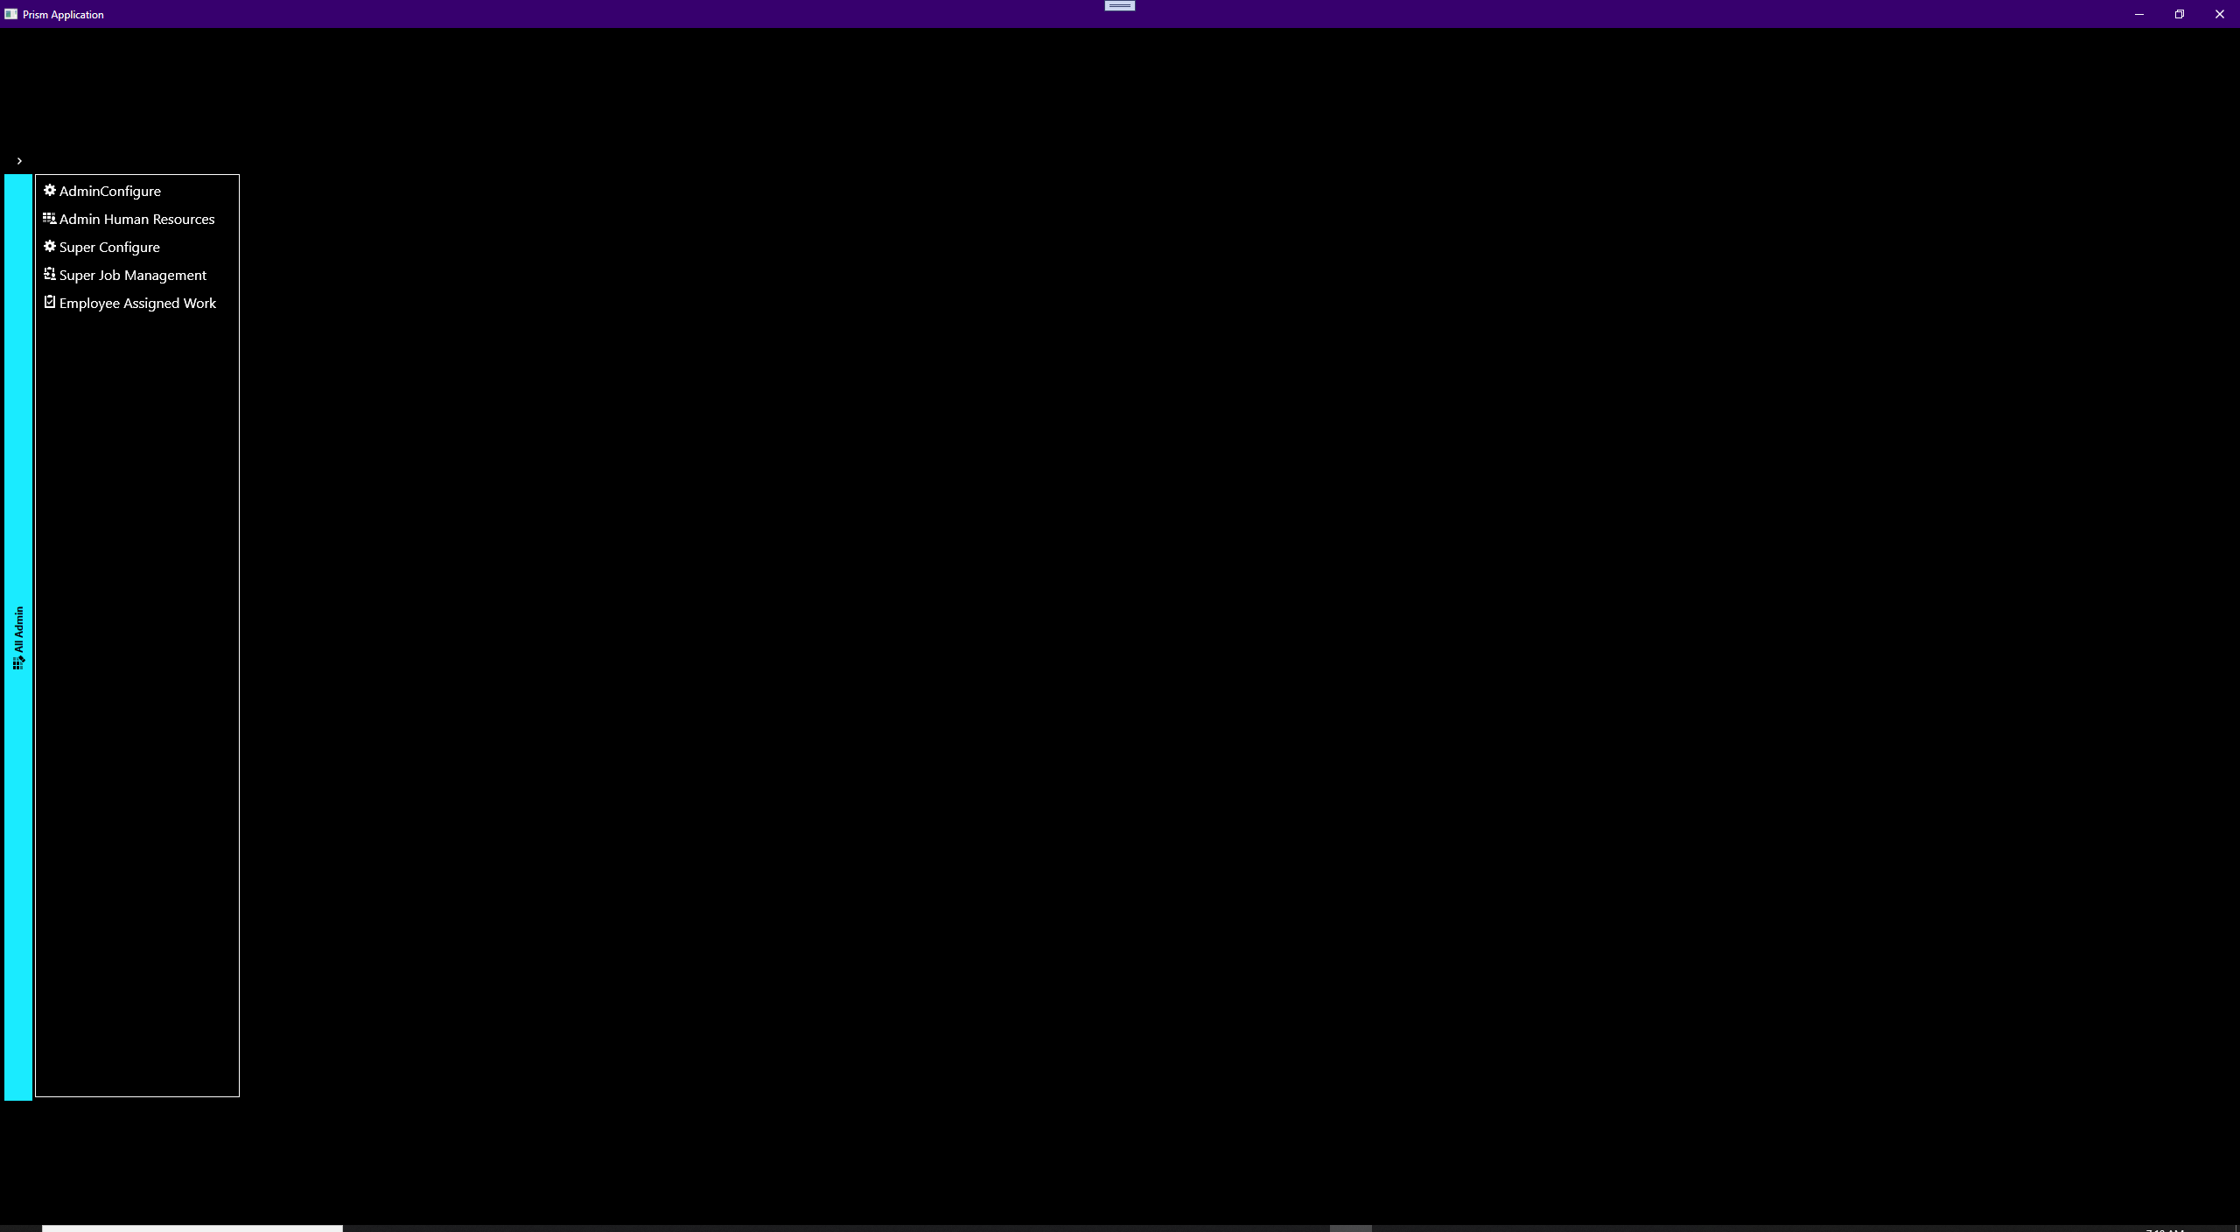

* Accordion arrow at the top hides and shows the accordion panel.
  + The arrow is positioned top right when accordion panel is displayed.
  + The arrow is positioned top left when accordion panel is displayed.
* The All Admin indicator temporarily expands the accordion panel.
  + The accordion is fully functional when the panel is this state.

# Administration Configure Screen

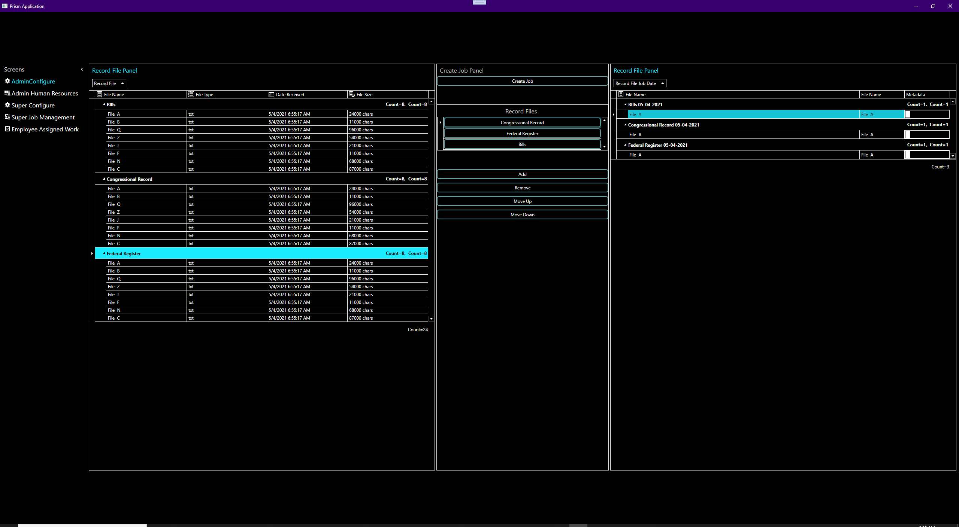

* Accessed via clicking on Admin Configure Accordion Item
* Three Sections
  + Record File Panel
    - The grid shall be displayed initially in a closed state.
    - When a grid item is expanded the corresponding information shall be loaded.
    - The grid shall implement drag functionality.
    - Column images may be omitted.
    - Possible tool- tips added.
  + Create Job Panel
    - Panel of button
  + Record File Panel
    - Should change title of panel.
    - The grid shall implement drop functionality.
  + Might want to add resizing, and auto hide capability to each section.

## Record File Panel Toggle Switch

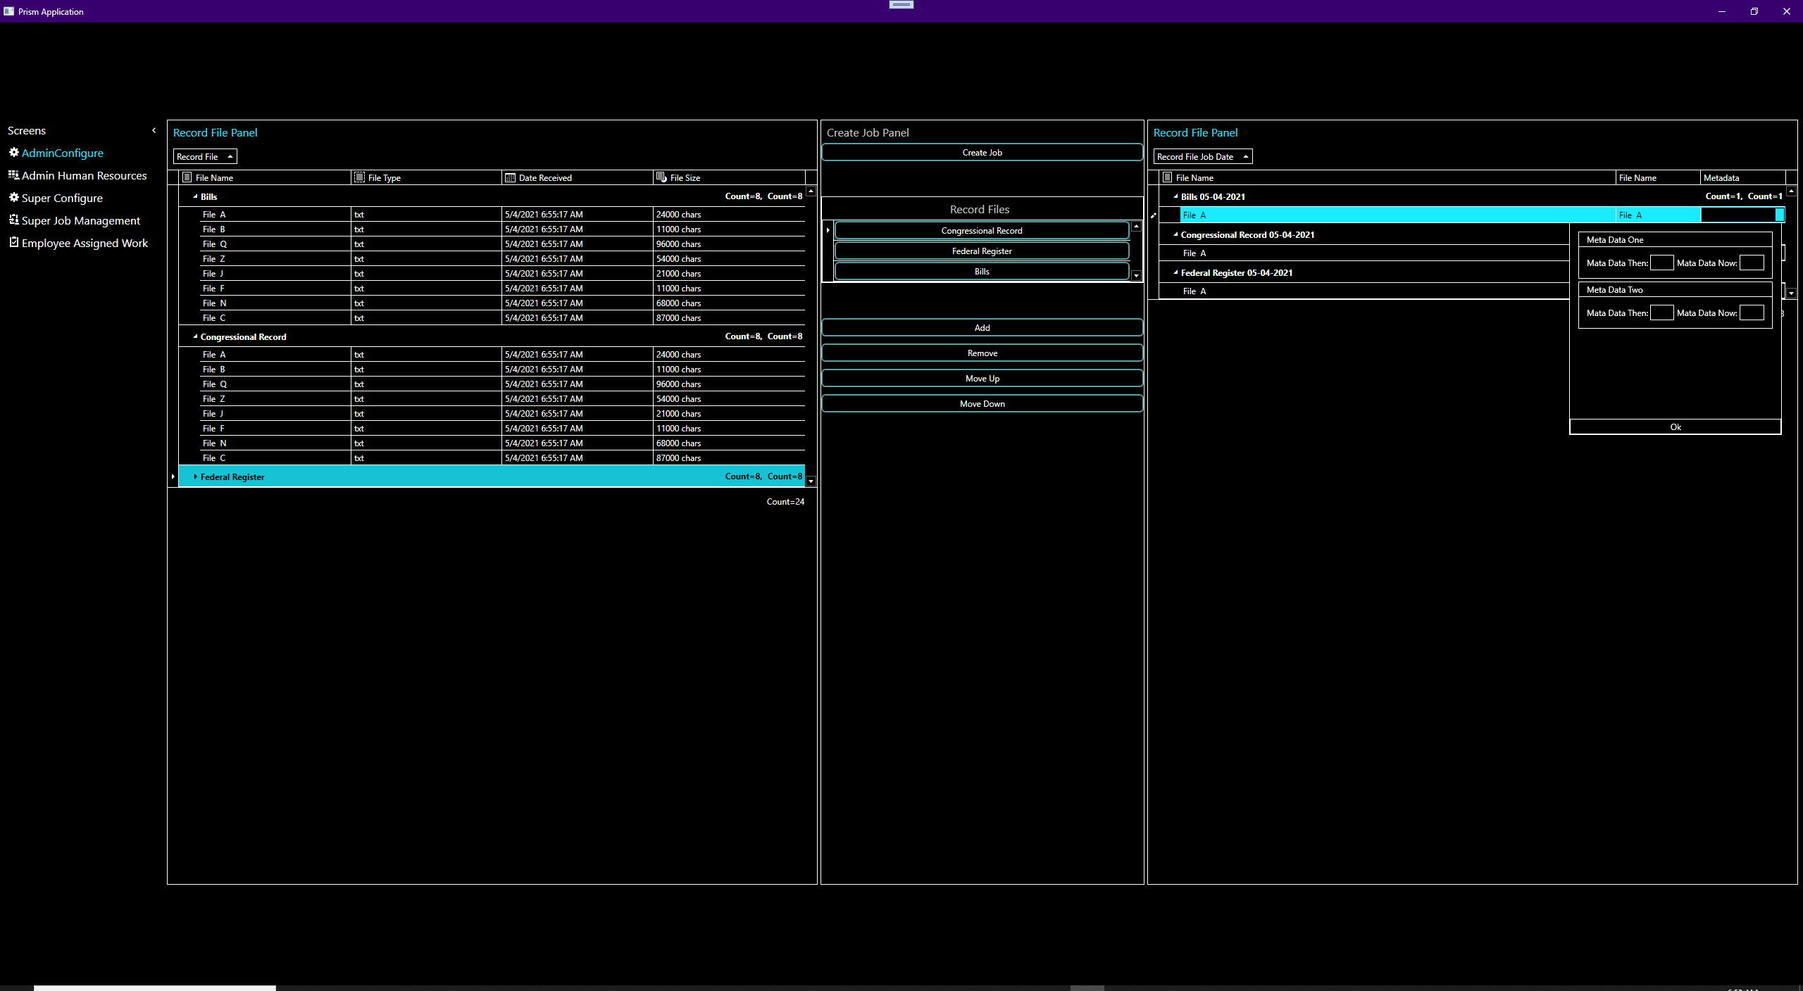

* Maybe want to modify pop window’s view.
* May want to replace pop up window’s view with the view being directly place corresponding row where its visibility is controlled by toggle switch’s state.

# Admin Human Resources Screen

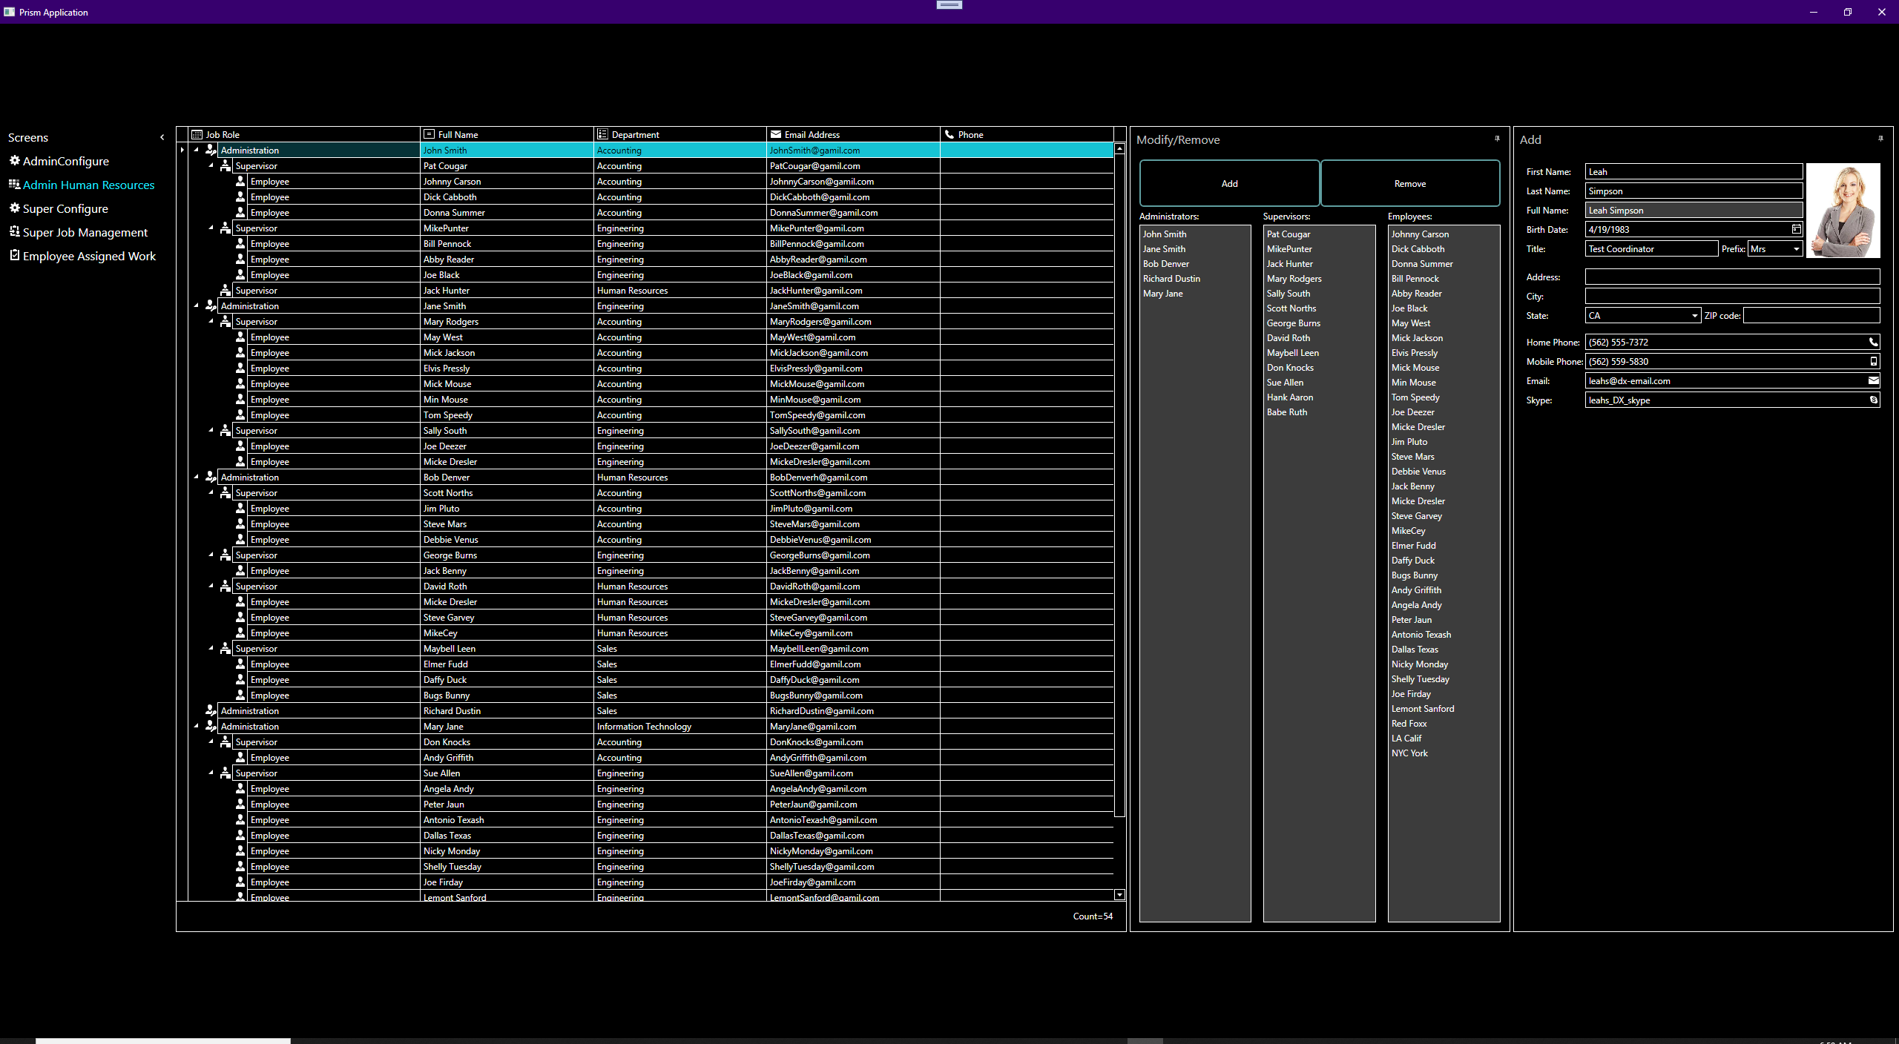

* Accessed via clicking on the Admin Human Resources Item
* Three Panels
  + Employee Grid Panel
    - Panel opens up pinned.
    - Displays all employees in a grid tree fashion.
    - Grid shall be displayed initially in a closed state.
    - When a grid item is expanded the corresponding information shall be loaded.
    - Grid shall implement drag and drop functionality.
    - Grid shall implement Insert/Remove/Modify functionality
    - Grid shall implement Batch capability.
  + Modify / Remove Panel
    - Opens up pinned.
    - Reflects all the employees in the grid.
    - Used to modify and remove employees from the grid.
    - Should implement drag functionality.
  + Add Panel
    - Opens up pinned.
    - Used to insert new employees and modify existing.
    - Displays employee selected in the grid.
    - New and modified employees are reflected in the grid.
    - Should implement frag and drop functionality.

## Panel Auto Hide

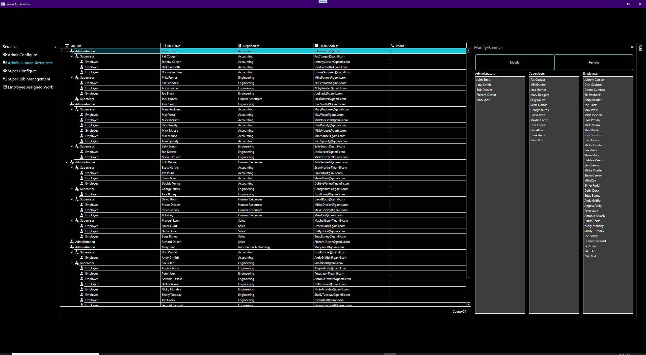

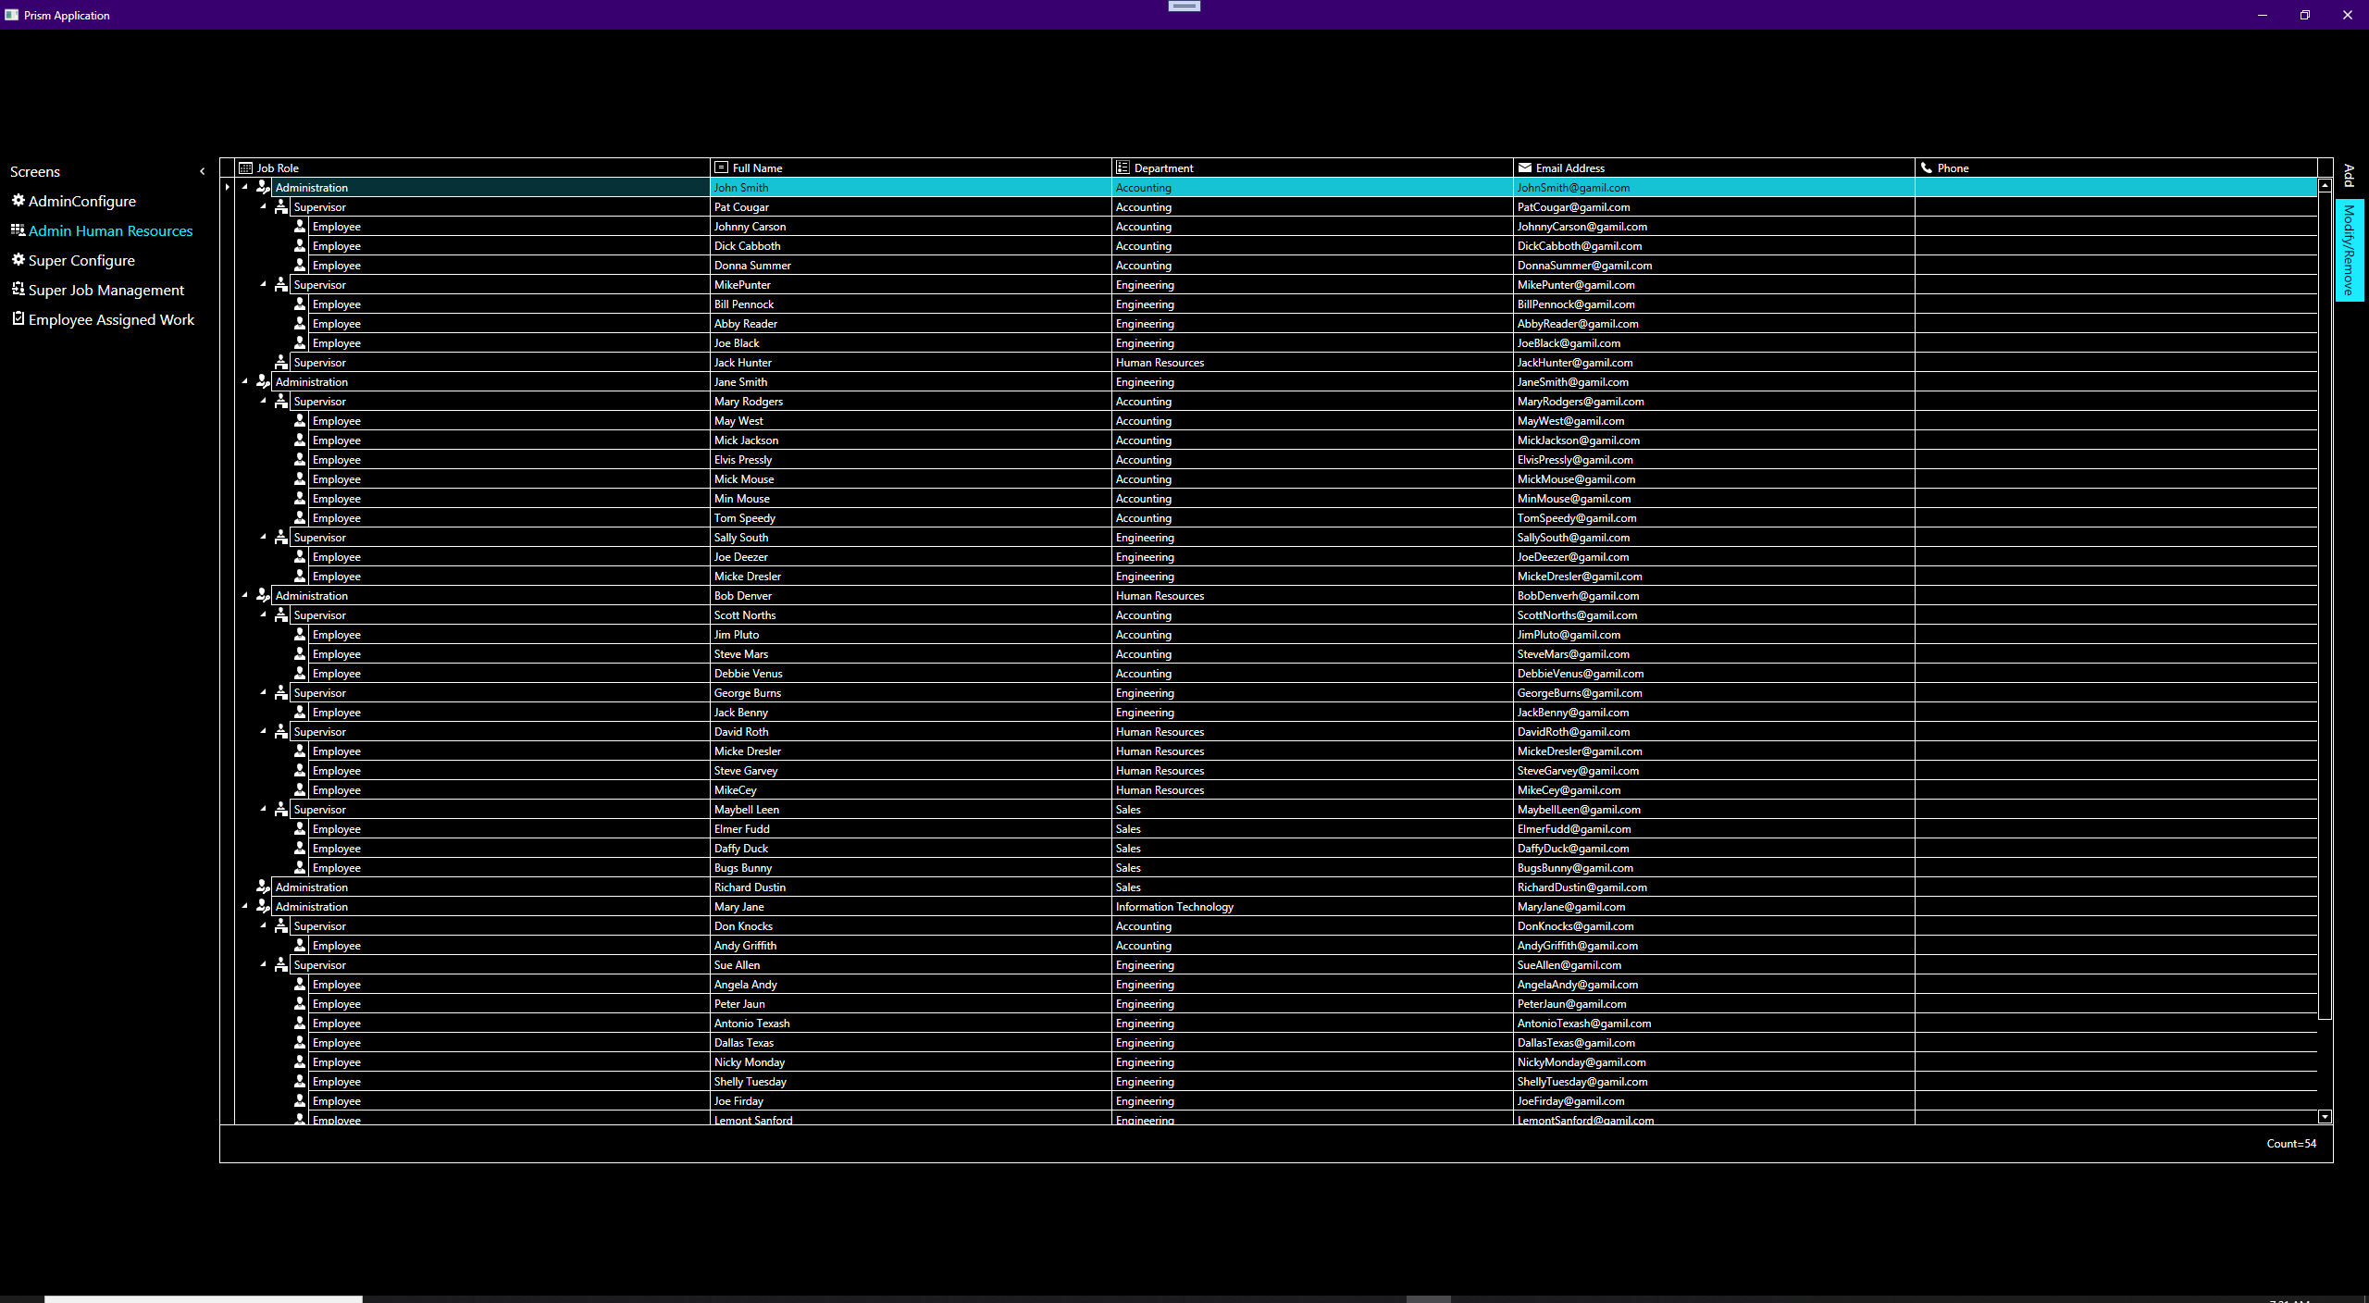

* Auto hide a panel by unpinning.

## Panel Slide Out

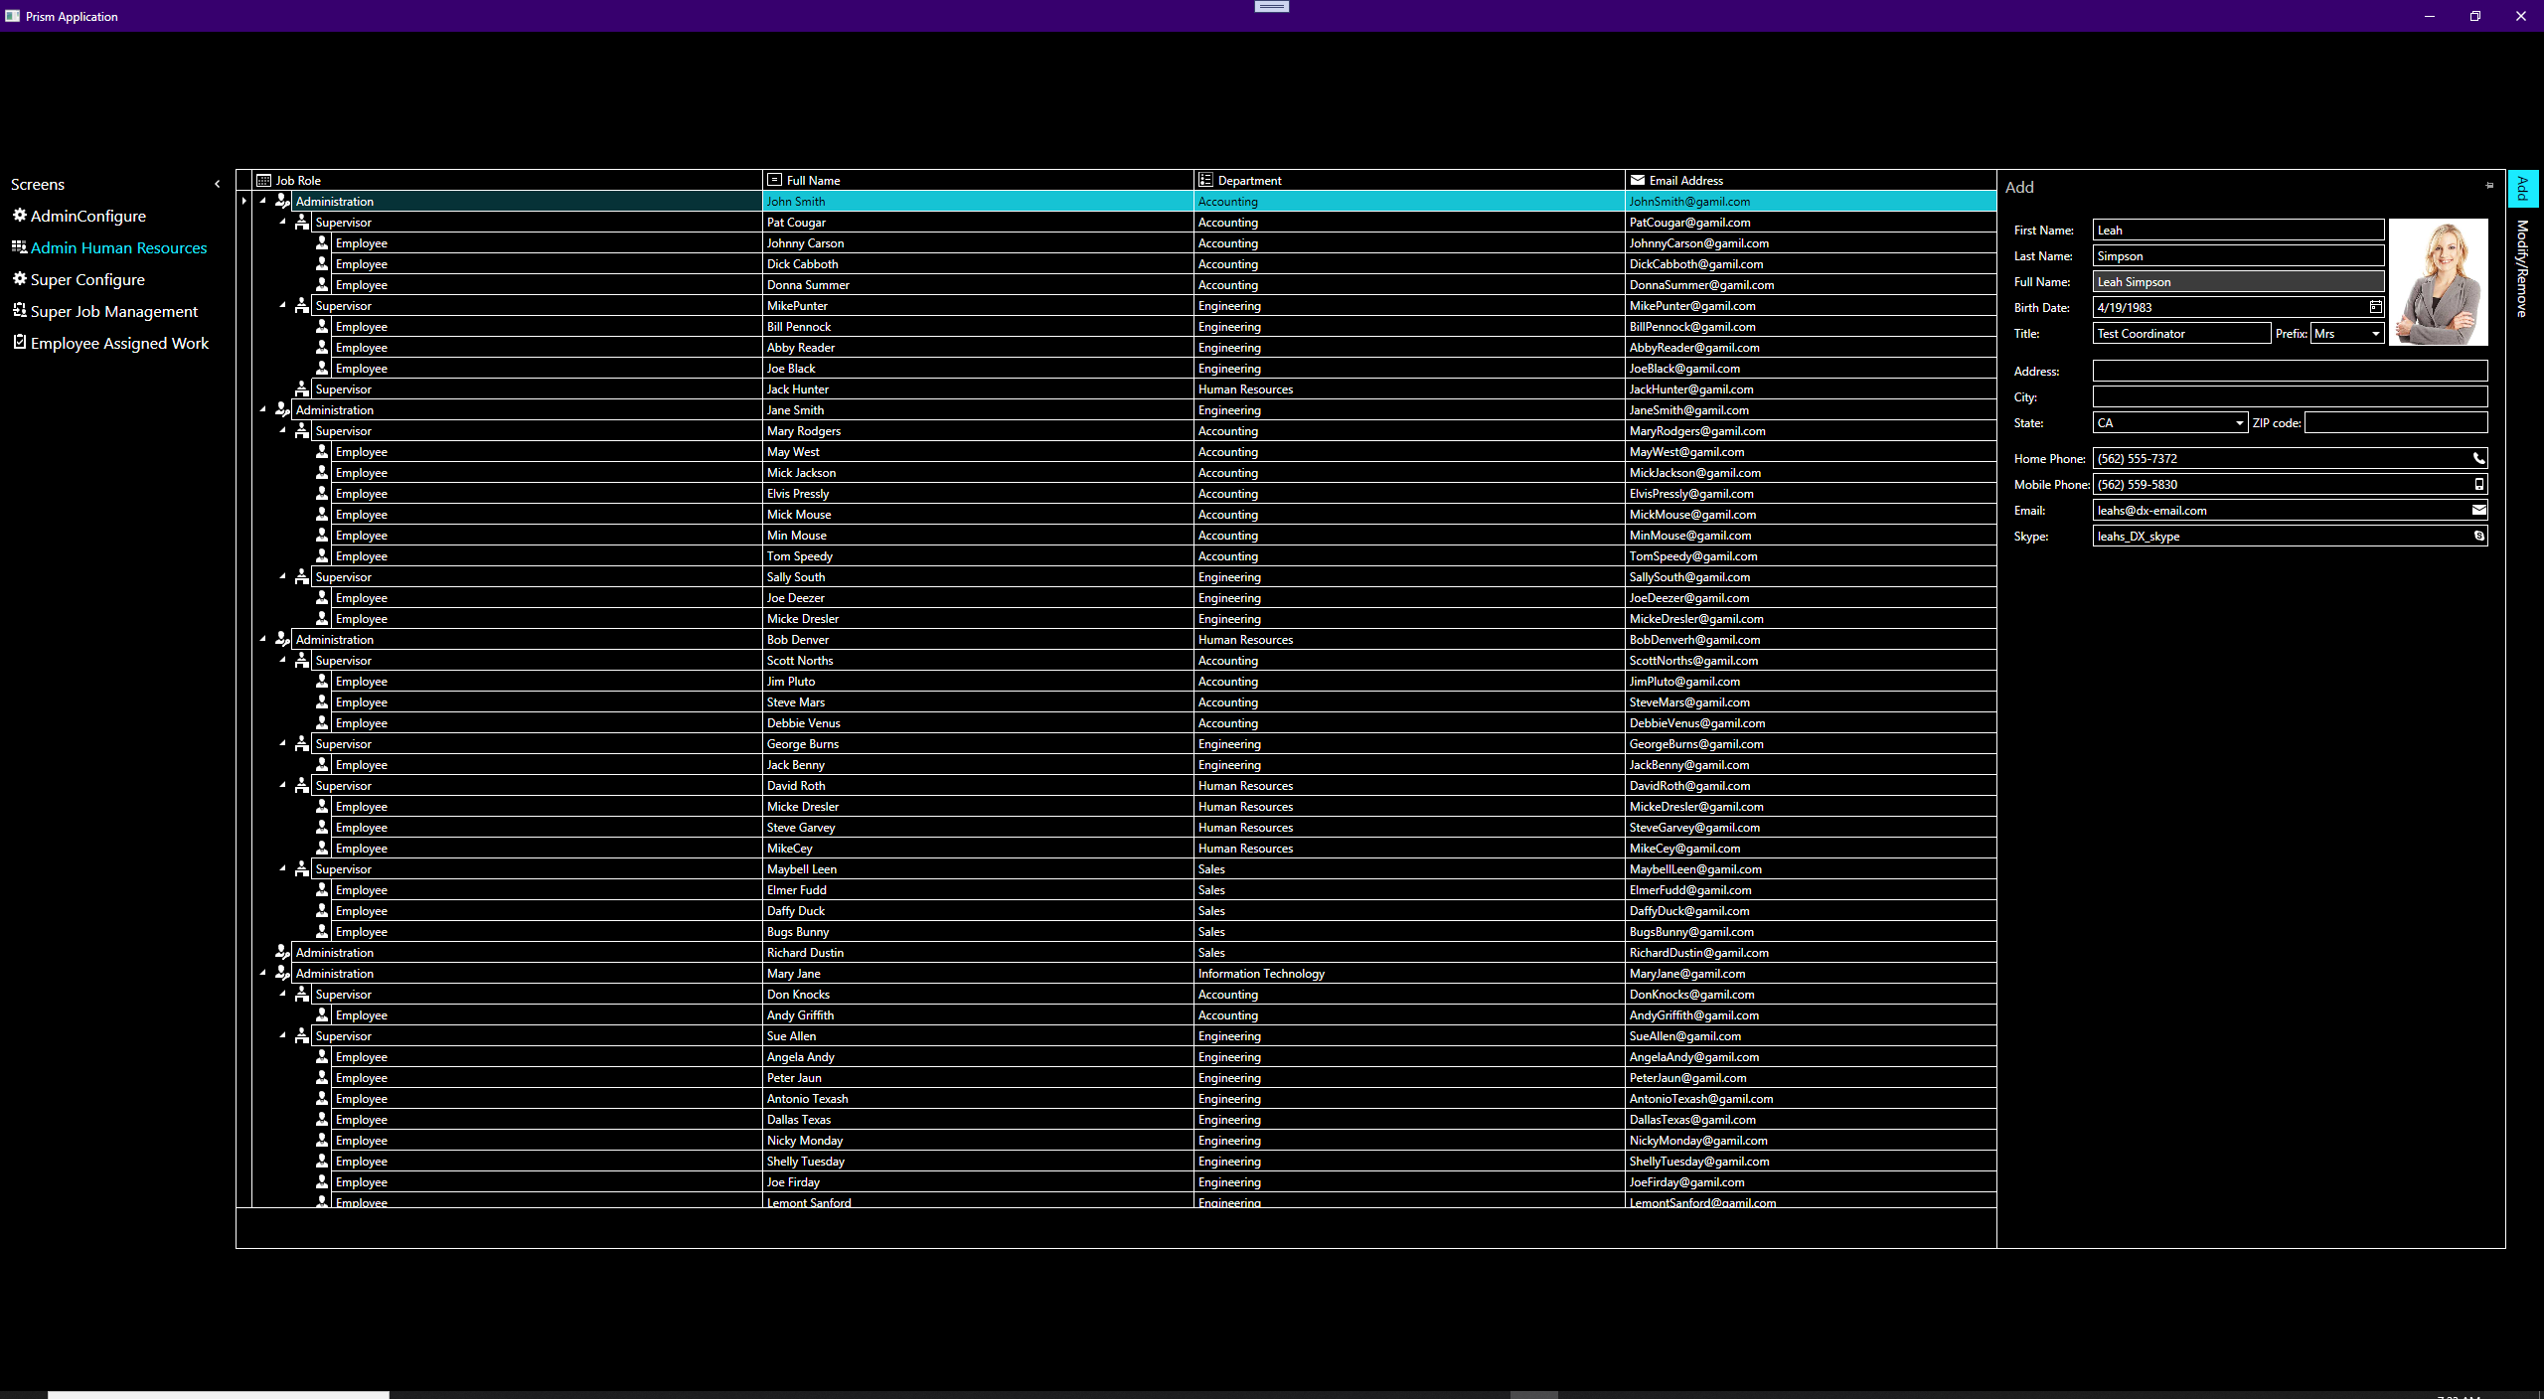

* Accessed by placing mouse over the tab.
* Functionality available just as it was when panel was pinned.
* Display Panel permanently by pinning it.
* Might want to make panels into a tabbed document.

# Super Configure Screen

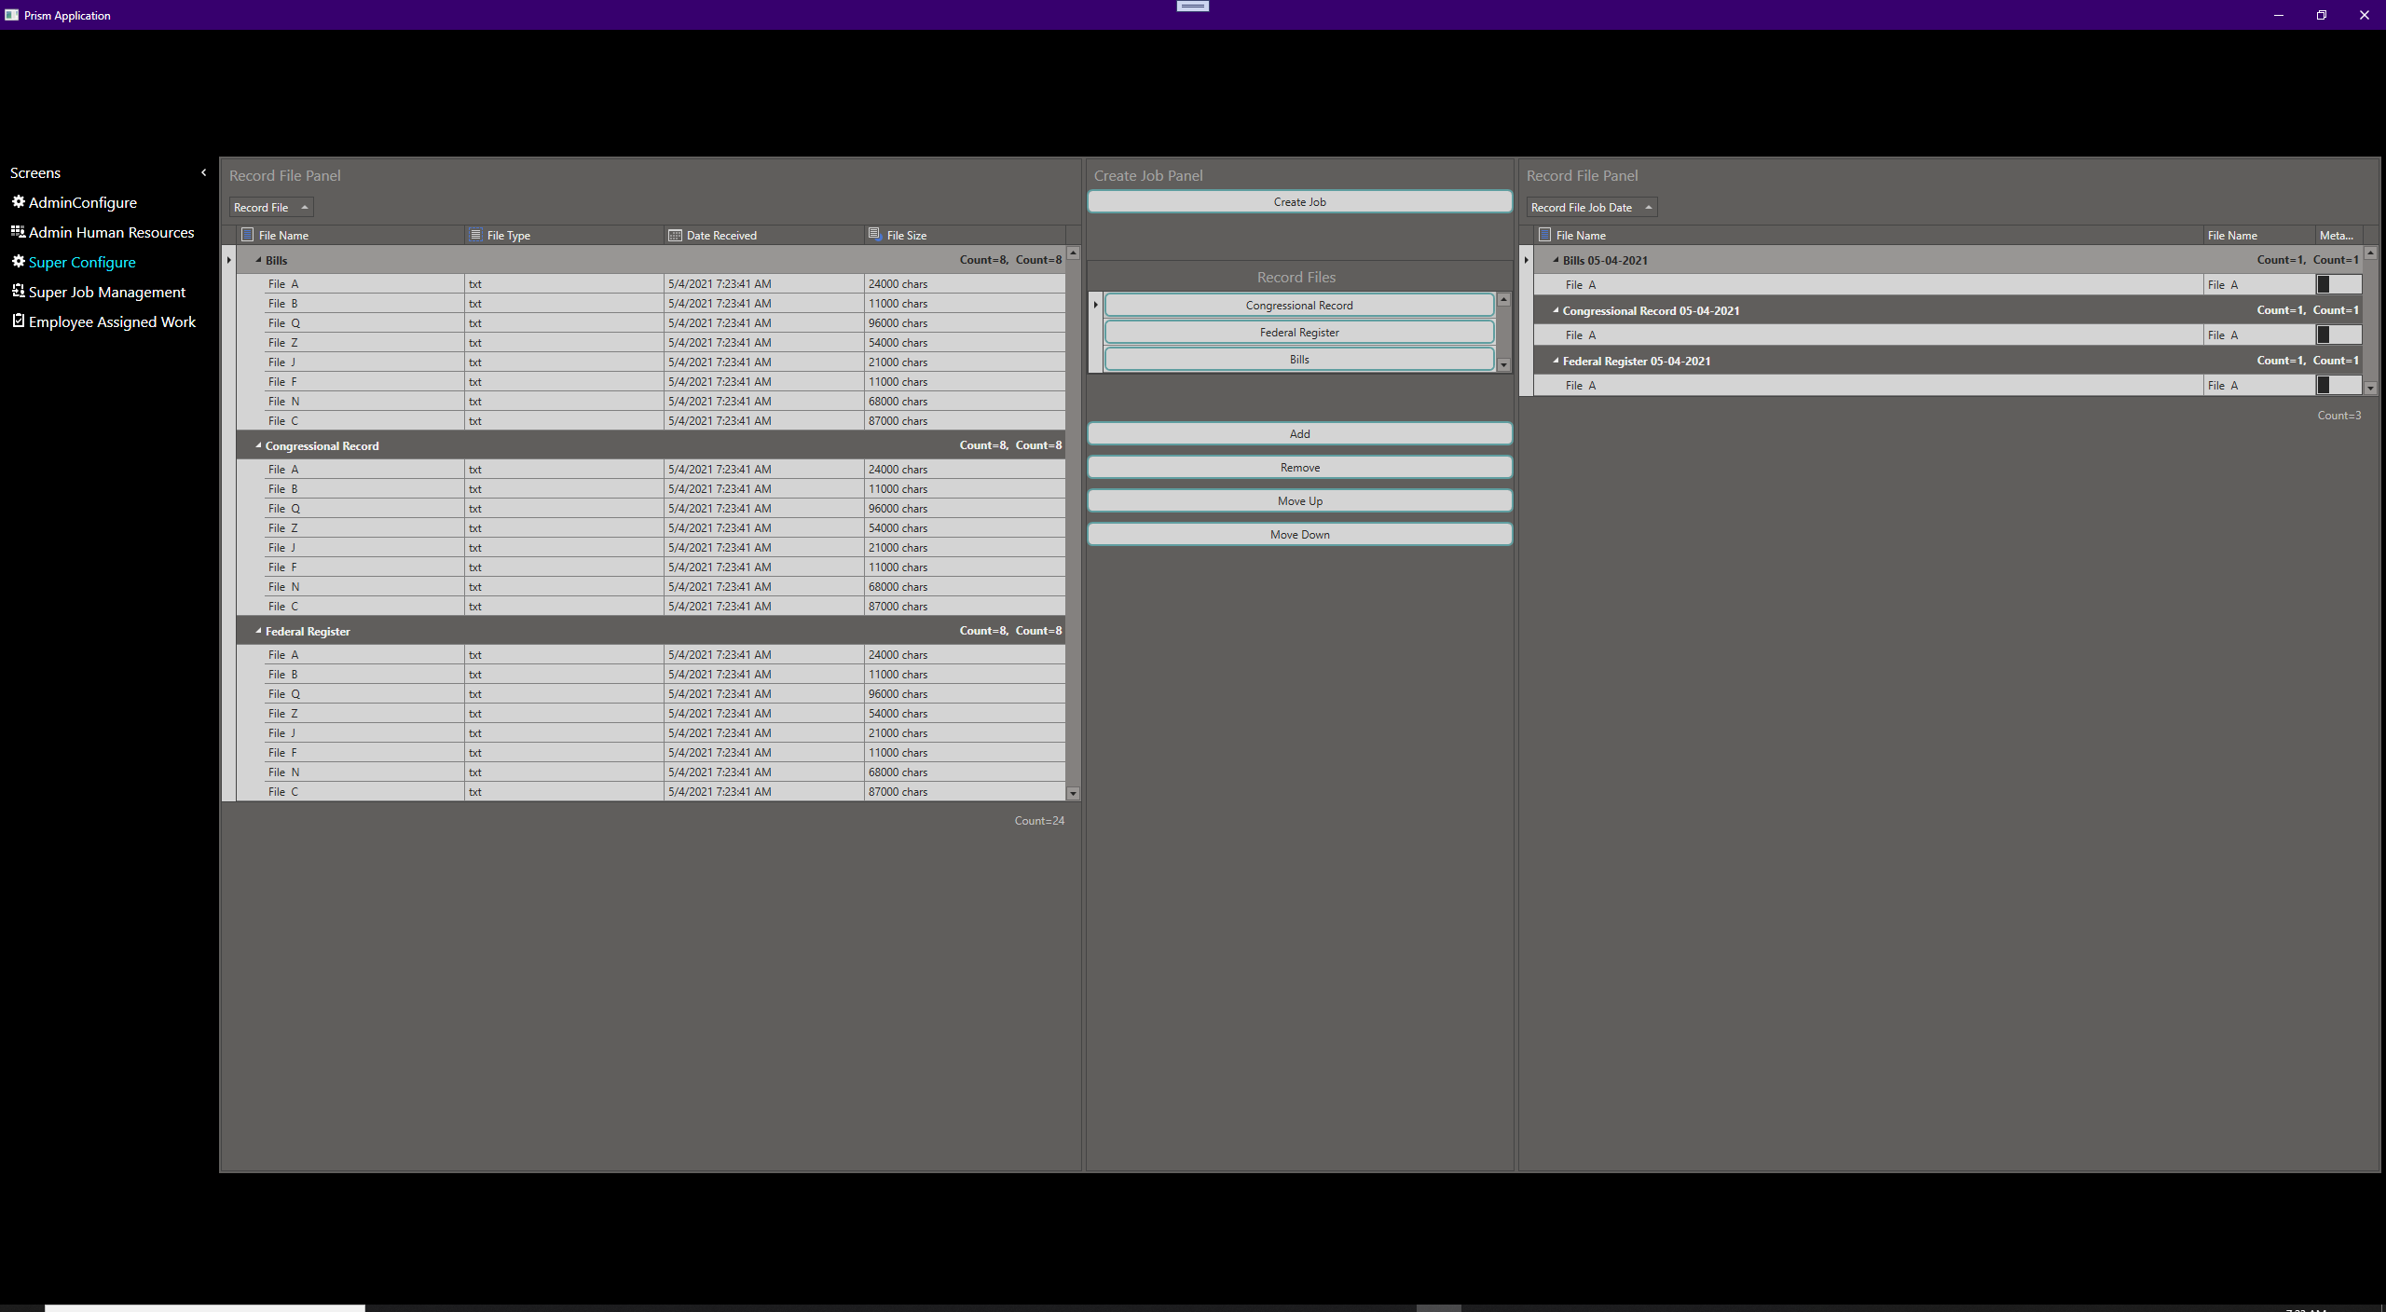

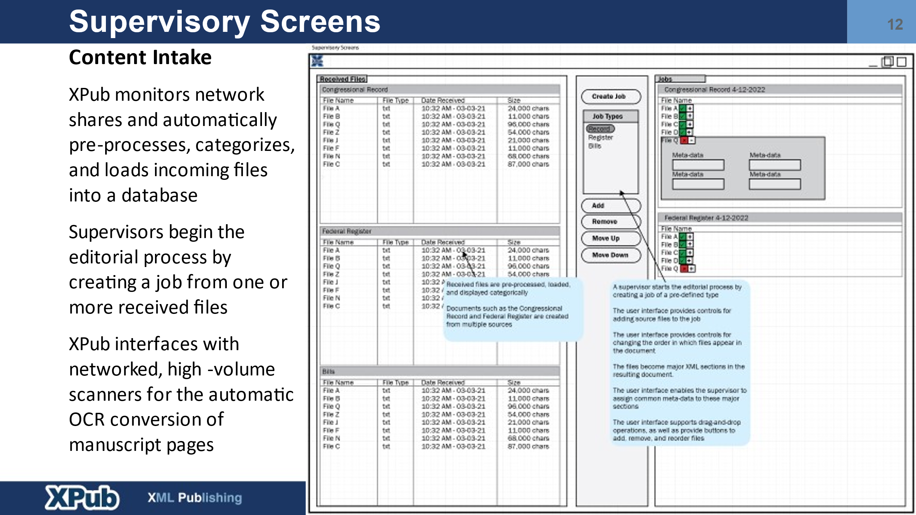

* Accessed by clicking on the Super Configure Accordion item
* Three Sections
  + Record File Panel
    - The grid shall be displayed initially in a closed state.
    - When a grid item is expanded the corresponding information shall be loaded.
    - Grid shall implement drag functionality.
    - Column images may be omitted.
    - Possible tool- tips added.
  + Create Job Panel
    - Panel of button
  + Record File Panel
    - Should change title of panel.
    - The grid shall be displayed initially in a closed state.
    - When a grid item is expanded the corresponding information shall be loaded.
    - Grid shall implement drop functionality.
  + Might want to add resizing, and auto hide capability to each section.

## Record File Panel Toggle Switch

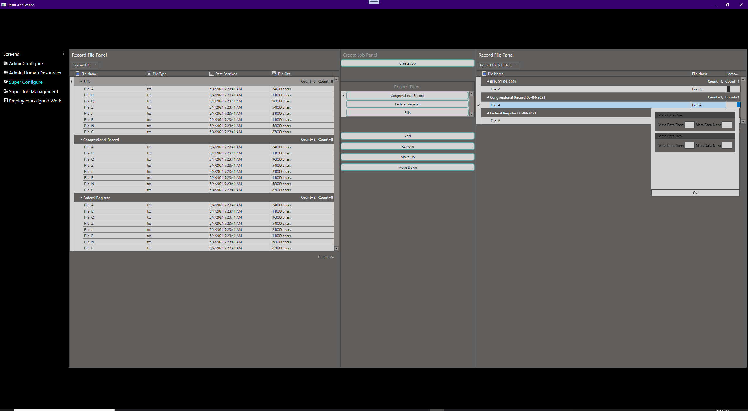

* Maybe want to modify pop window’s view.
* Hard to read text in pop up window.
* May want to replace pop up window’s view with the view being directly place corresponding row where its visibility is controlled by toggle switch’s state.

# Super Job Management Screen

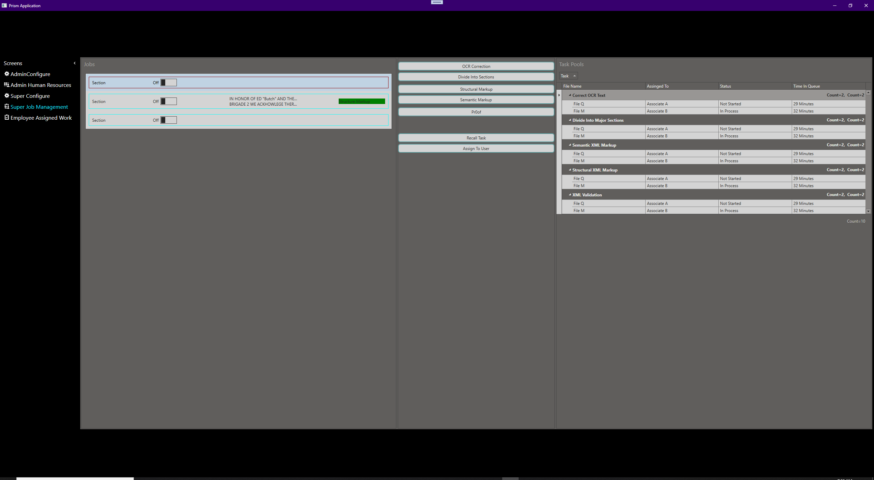

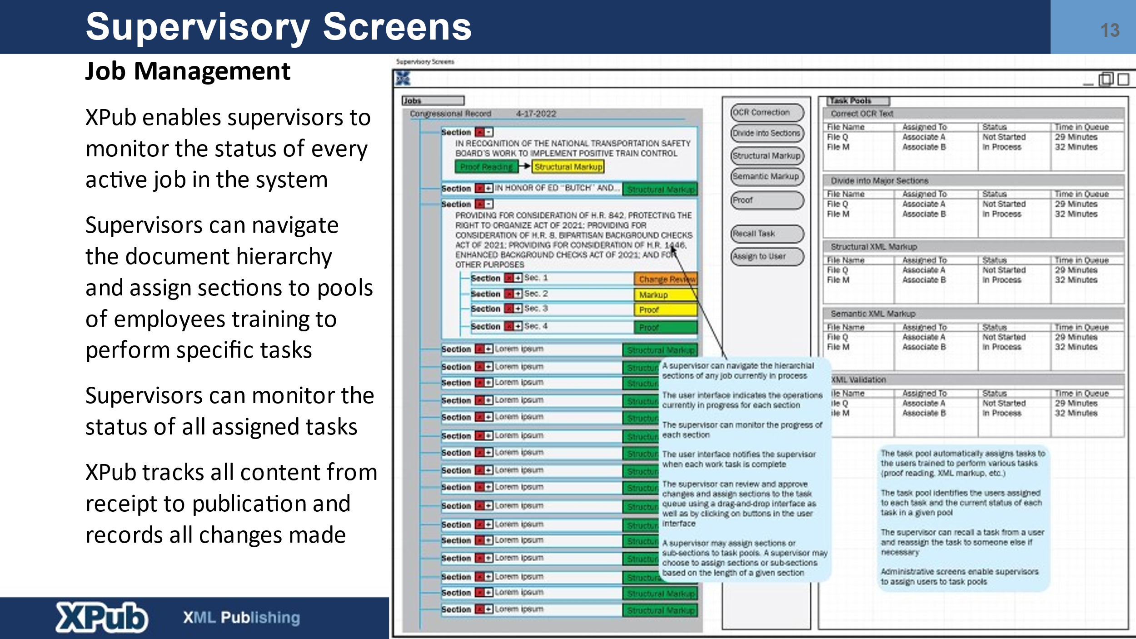

* Accessed via clicking on the Super Job Management Accordions Item
* Three Sections
  + Jobs Section
    - The grid shall be displayed initially in a closed state.
    - When a grid item is expanded the corresponding information shall be loaded.
    - Grid shall implement drag functionality.
    - A grid item (section) shall be expanded and collapses using a toggle switch.
    - Section border color shall be used to indicate if a section has additional sections.
  + Button Section
    - Affect Task Pool Section
  + Task Pool Section
    - The grid shall be displayed initially in a closed state.
    - When a grid item is expanded the corresponding information shall be loaded.
  + Might want to add resizing, and auto hide capability to each section.

## Jobs Section Various Screens



* A Section should be loaded when open via Toggle Switch.
* Rich Edit Text Control should be auto sized in height to match content.
* Rich Edit Text Control should be given a minimum and maximum height.
* Section is bordered in represent on of two states.

# Employee Assigned Work Screen

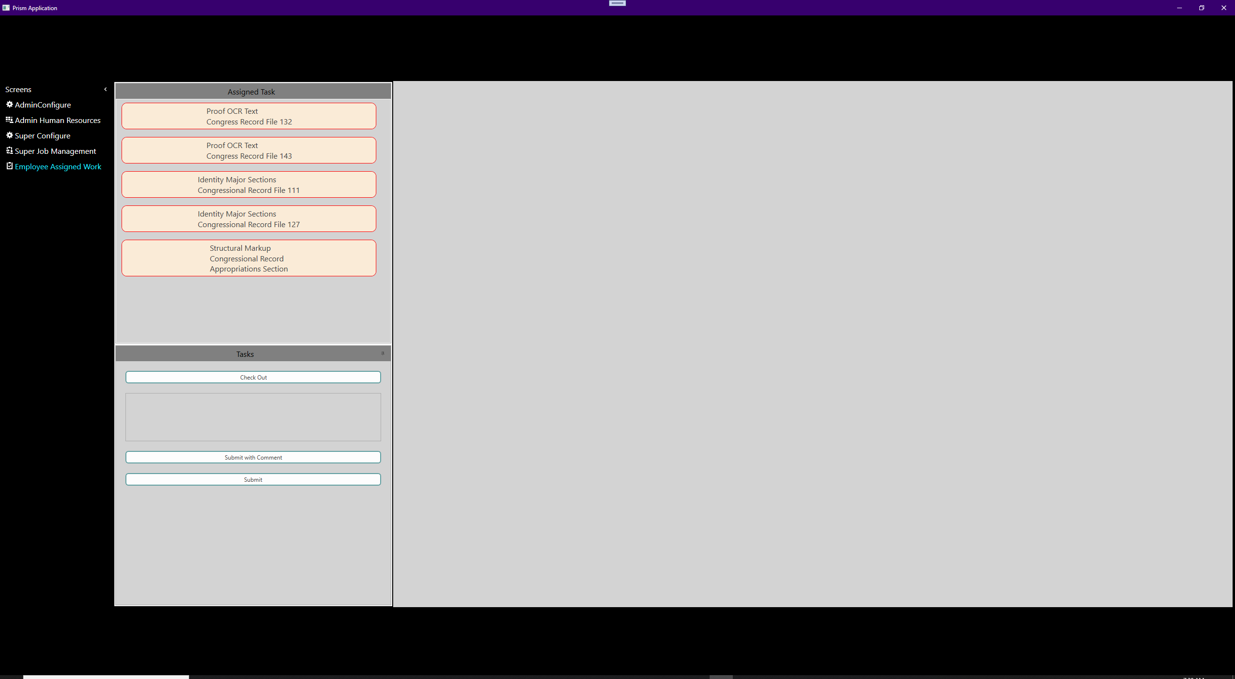

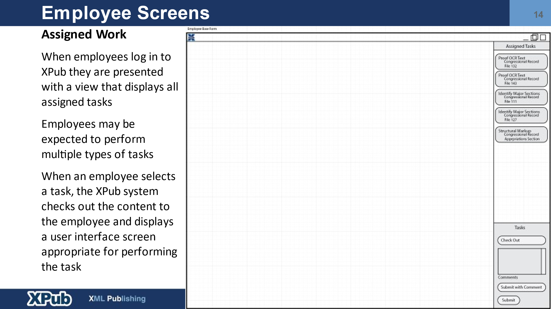

* Accessed via clicking on the Super Job Employee Assigned Work
* Two Sections
  + Task Section
    - Contains Assigned Task Section.
      * Displays assigned tasks.
      * Displays an assigned task screen in the view section.
      * Assigned task is active while corresponding screen is displayed in the view section.
      * A screen shall be displayed in one of several states.
      * A screen state shall be indicated by the color of the active assigned task.
    - Contains Task Section
      * Affects the state of the assign task’s screen displayed in the view.
  + View Section
    - Displays an assigned task’s screen.

# Employee OCR Correction Screen

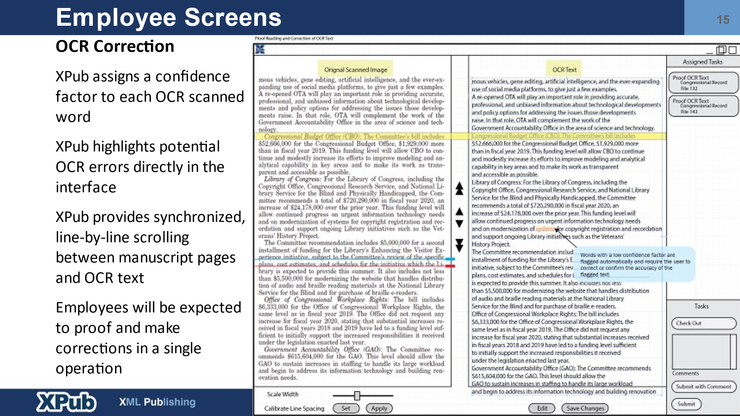

# Employee Identifying High-Level Structure Screen